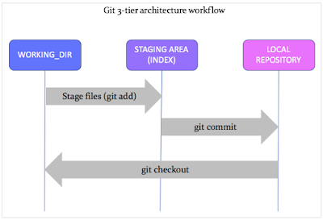

**Fig 1.** Three stage architecture diagram of GIT.